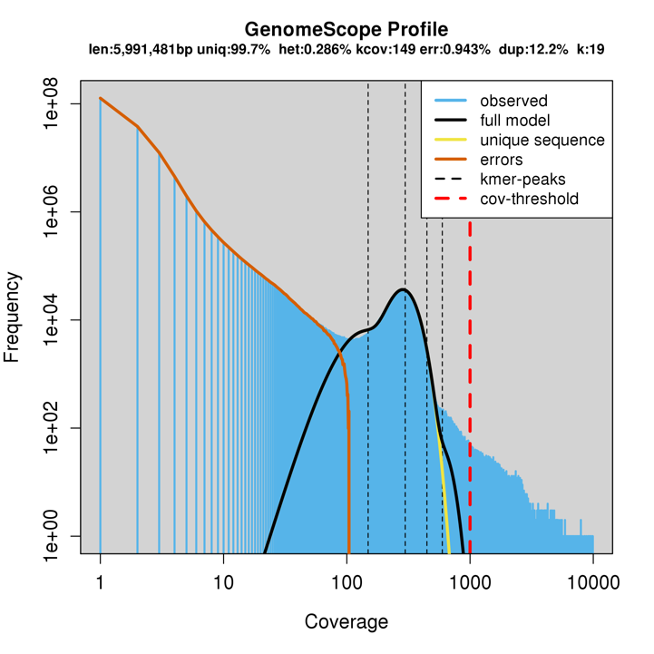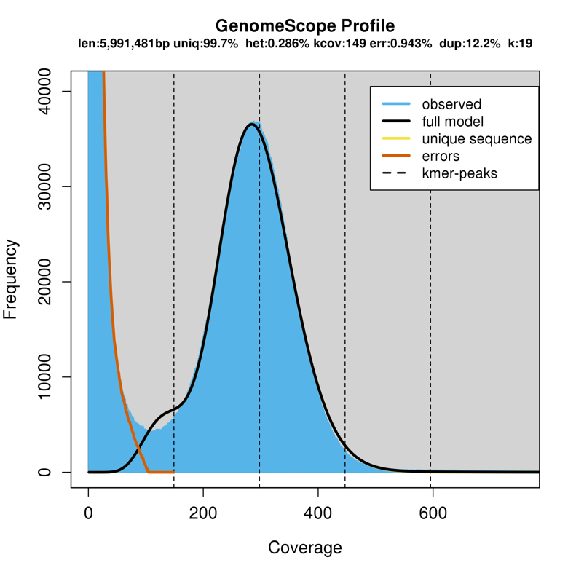

Results 2338_one_pair_size_estimate:

GenomeScope version 1.0

k = 19

property min max

Heterozygosity 0.244326% 0.328491%

Genome Haploid Length 5,922,758 bp 5,991,481 bp

Genome Repeat Length 19,655 bp 19,883 bp

Genome Unique Length 5,903,103 bp 5,971,599 bp

Model Fit 95.4178% 95.6635%

Read Error Rate 0.942657% 0.942657%